Lab 6.1 Working with Labels

- Create a pod with labels “environment=staging” and “team=kube-team” using a pod-definition.yml file
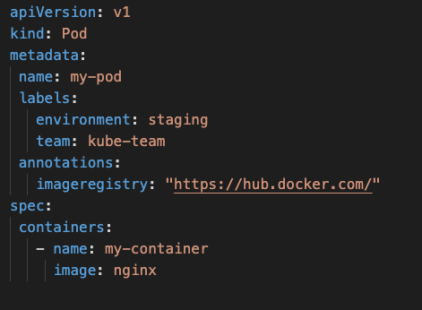

- Check that the labels are applied in the newly created pod:
kubectl get pod my-pod --show-labels

- Add a label to a pod using Kubectl:
kubectl label pod my-pod versionID=ver0.9

- Remove a label from a pod using Kubectl:
kubectl label pod my-pod versionID-

- Update a label for a pod using Kubectl:
kubectl label --overwrite pods my-pod team=ops

- Create an nginx deployment called myapp with two replicas and a label env =dev
kubectl run myapp --image=nginx --labels=”env=dev”

- Create another nginx deployment called myapp2 with two replicas and a label env=prod
kubectl run myapp2 --image=nginx --labels=”env=prod”

- View deployments with their respective labels displayed.
kubectl get pods --show-labels

- Let’s view a deployments labels env=dev from our previously created deployment.
kubectl get pods -l env=dev --show-labels
kubectl get pods --selector=”env=dev” --show-labels

- View all pods with labels env=dev and env=prod.
kubectl get pods -l 'env in (dev,prod)' --show-labels
kubectl get pods --selector="env in (dev, prod)" --show-labels

